TOP FLOOR FLAT, 15 DUKE STREET, TAVISTOCK

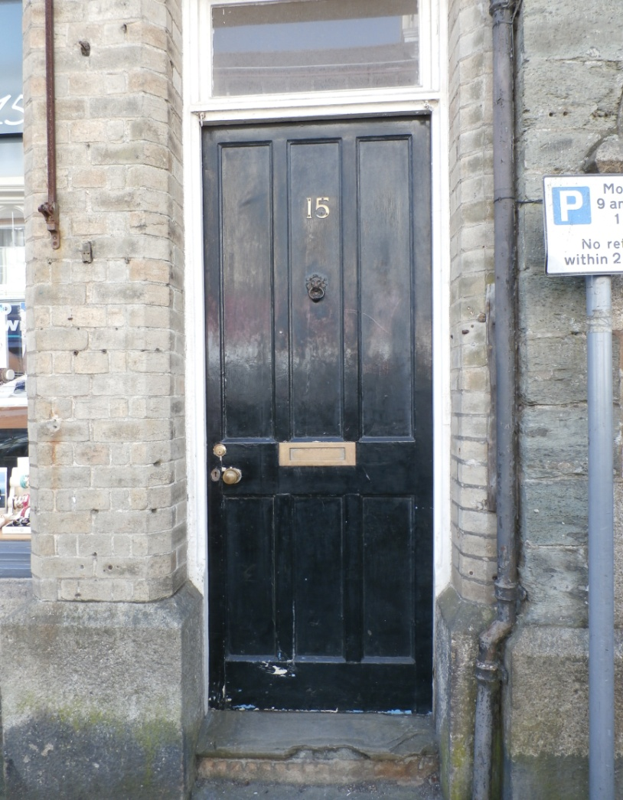

Drafted
13th July 2020

The property comprises 3/4 bedrooms, large lounge, dining room, hall, stairs and landing, bathroom, kitchen, WC and utility room.
GROUND FLOOR
Front door – brass letter box
Outer entrance hall (photos 1 & 2) – There is a hanging rail with 6 hooks affixed to the right hand wall. There is a painted door leading into the inner hallway.

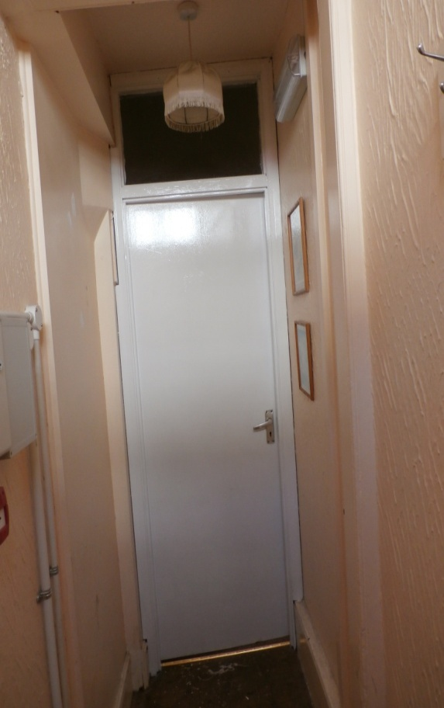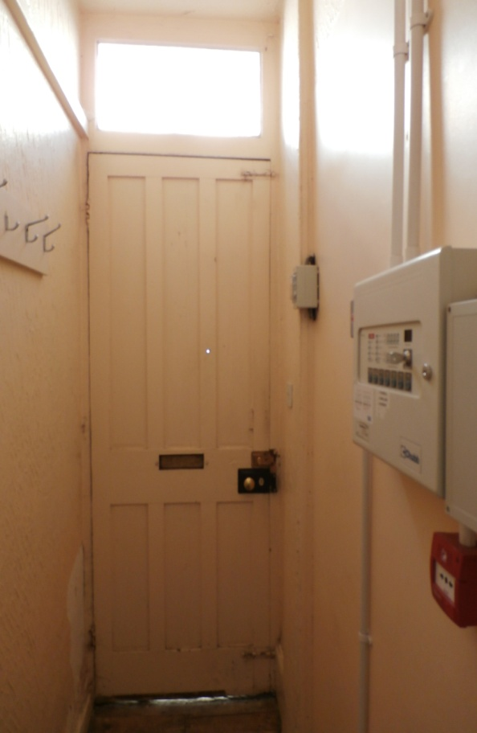
Photo 1 Photo 2

Inner entrance hall (photo 3) –
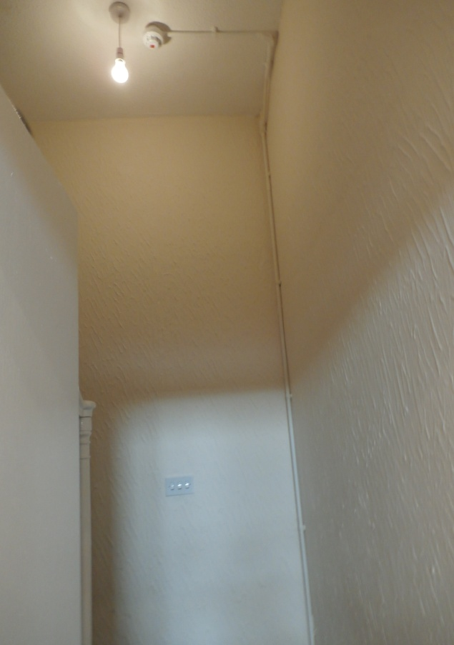
Photo 3
Separate WC (photos 4 & 5) – low level toilet and cistern, small hand basin, vinyl flooring

Photo 4 Photo 5
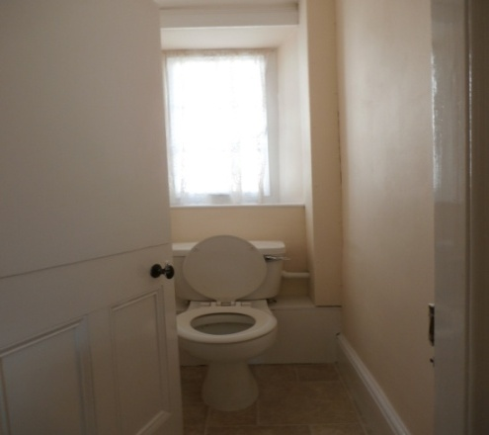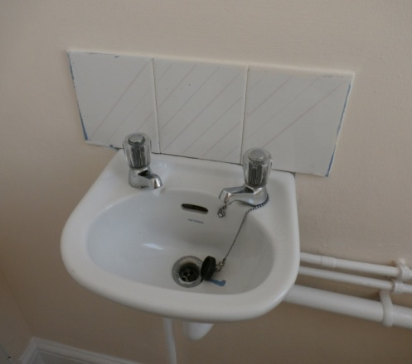

FIRST FLOOR
Small study/bedroom 4 (photos 6 & 7) – Newlec electric wall mounted heater. Fuse box mounted on wall behind the door.
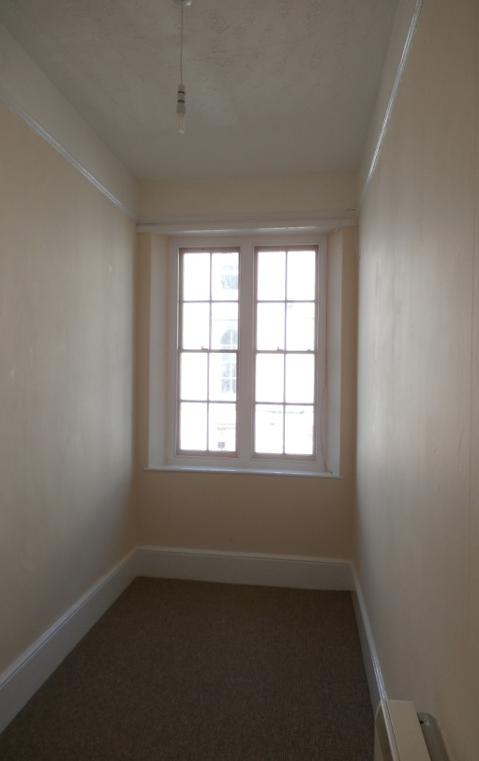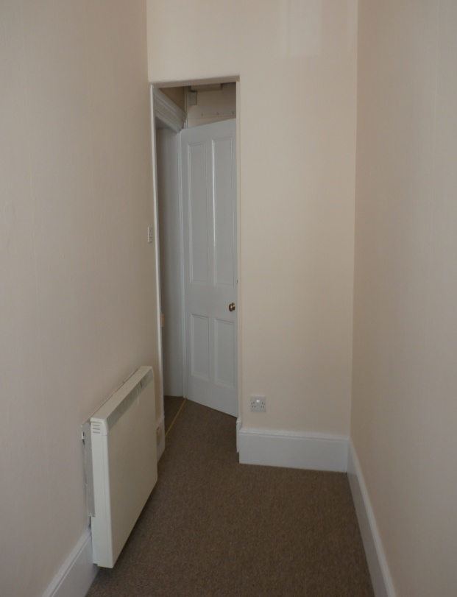
Photo 6 Photo 7
Dining Room (photo 8) – Newlec electric heater mounted in fireplace
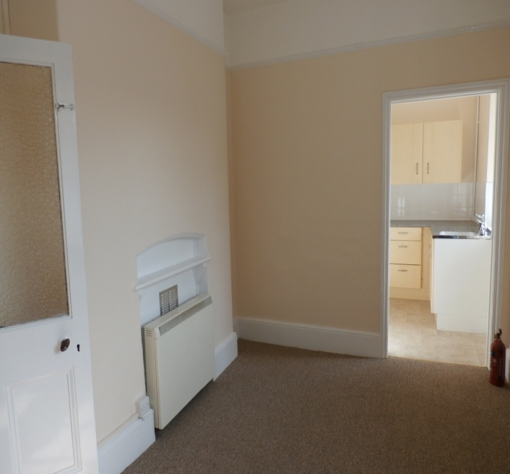 Photo 8

Kitchen (photos 9 - 11) – kitchen units/sink, vinyl flooring, tiled splashbacks. There is a single central florescent light fitting. A fridge/freezer and electric cooker have been left by the previous tenant. The Town Council has left these in situ for use by any incoming tenant, however it takes no responsibility for them. If they go wrong it will not undertake any repairs. These items can be removed if any new tenant would prefer.
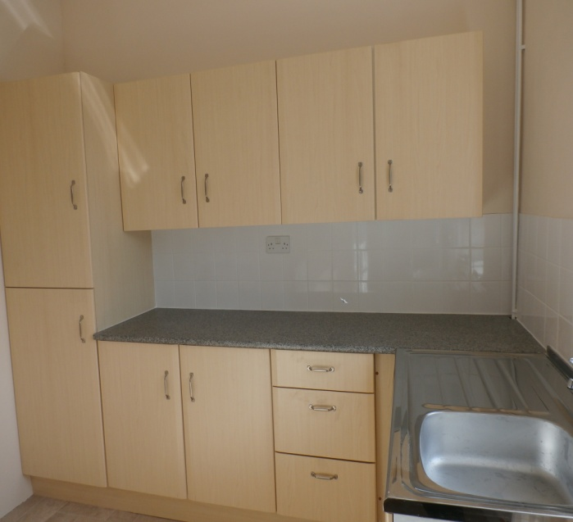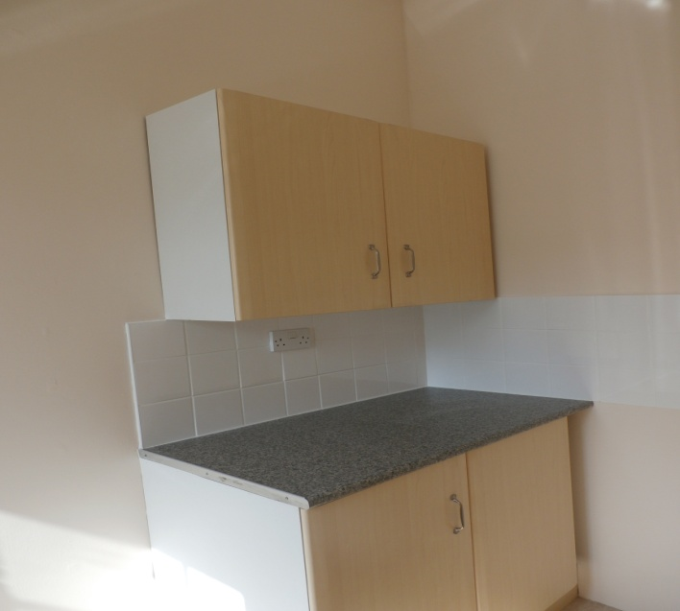
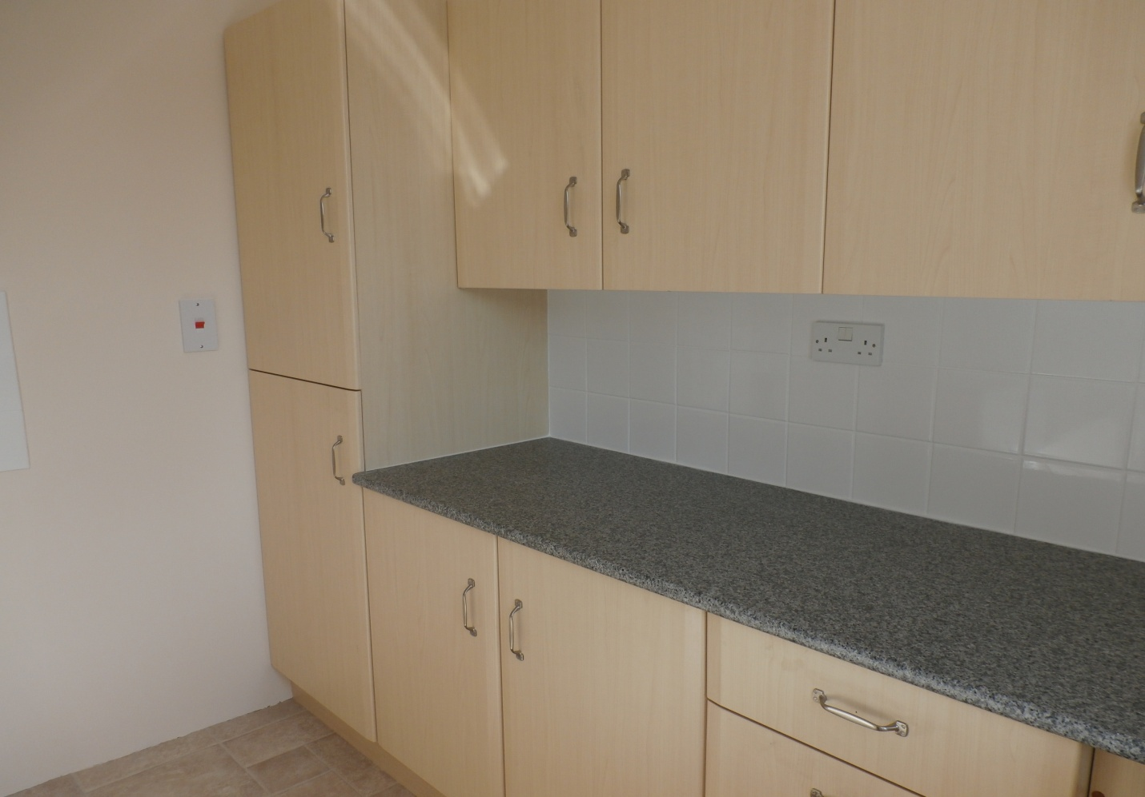
Photos 9 – 11

Lounge (photos 12 & 13) – Newlec wall mounted electric heater, single central light fitting. New carpet fitted.
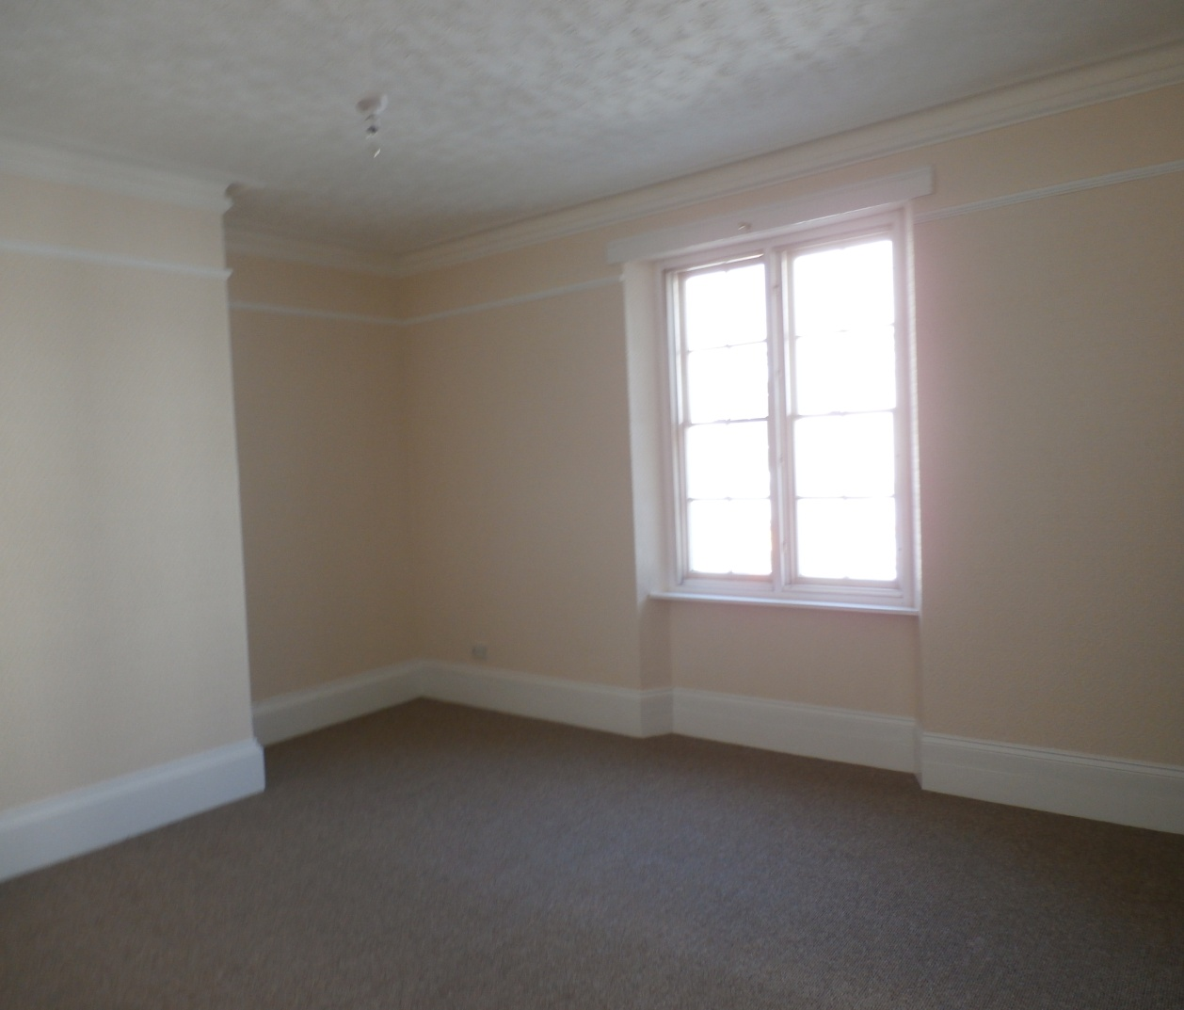
Photo 12
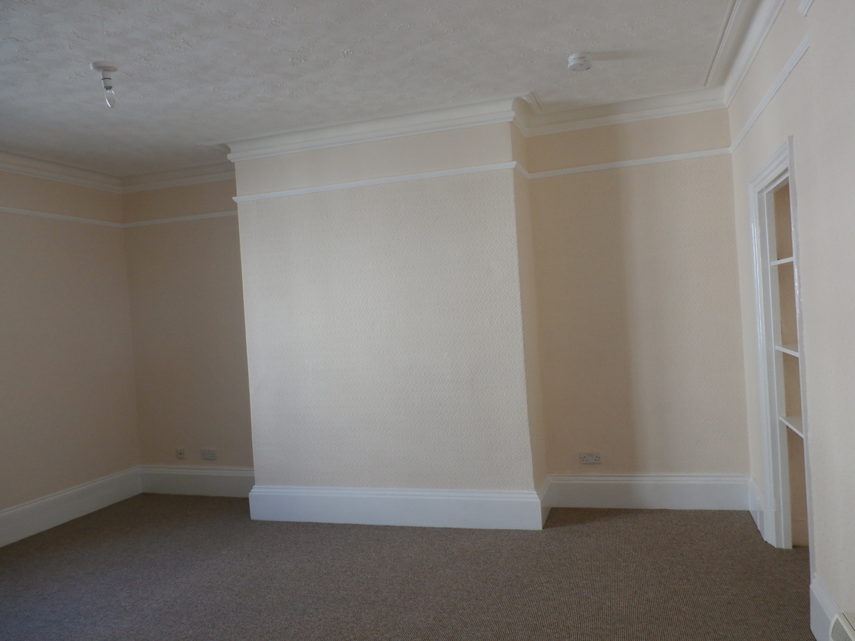
Photo 13
Stairs leading to SECOND FLOOR (photo 14 below)

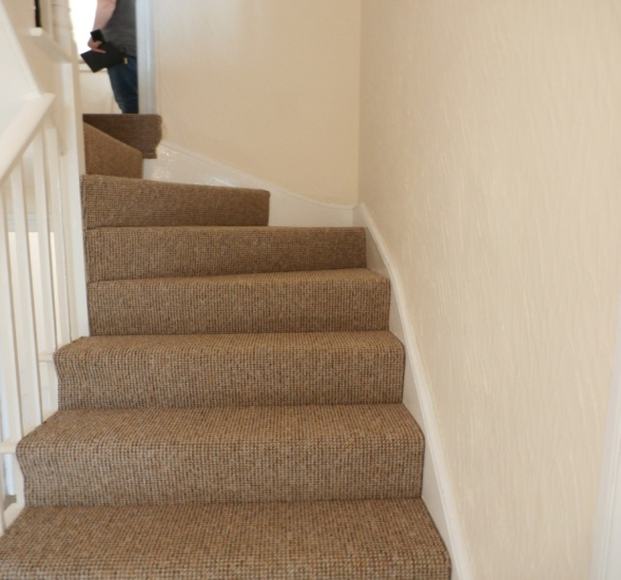
Utility area on mid-stairs (photo 15) – vinyl flooring. Hot/cold connections for washing machine plus high level painted shelving.
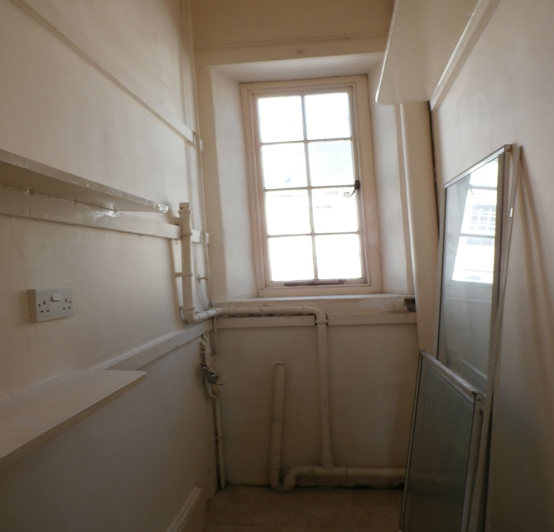 Photo 15

SECOND FLOOR
Bedroom 3 (photos 16 & 17) – Vanity unit (reasonable condition) with over-sink light/shaver point. Hanging rail behind door with 4 hooks.
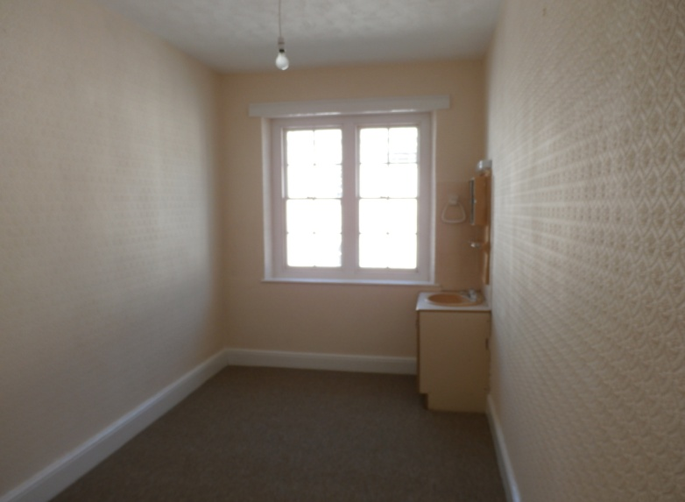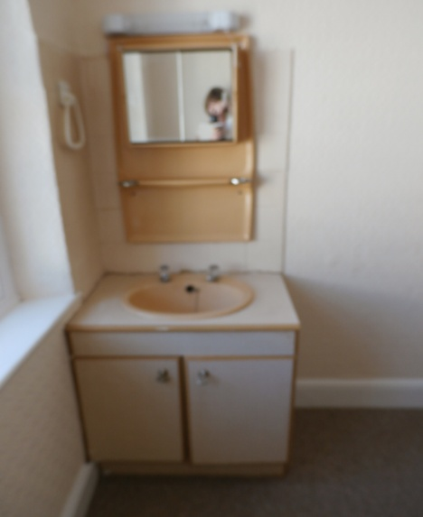
Photo 16 Photo 17

Bedroom 2 (photo 18)
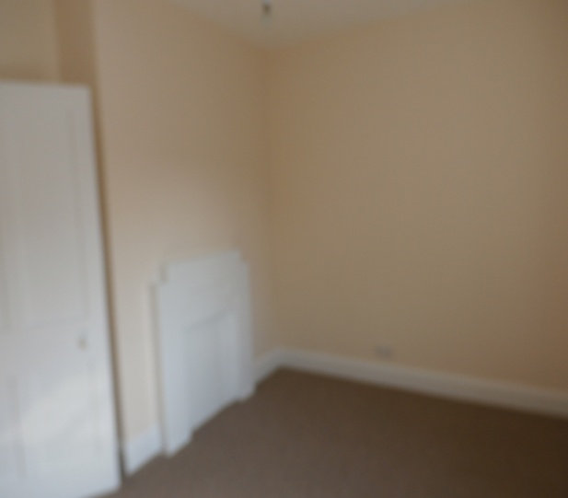
Photo 18
Bedroom 1 (photos 19-21) – built in double door cupboard. Free standing wardrobe left for new tenant’s use, (not as in picture) if required. Tavistock Town Council does not retain any responsibility for this item of furniture.
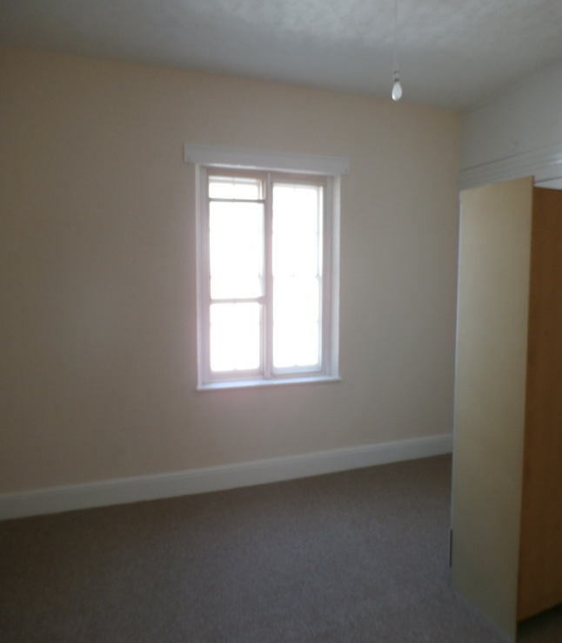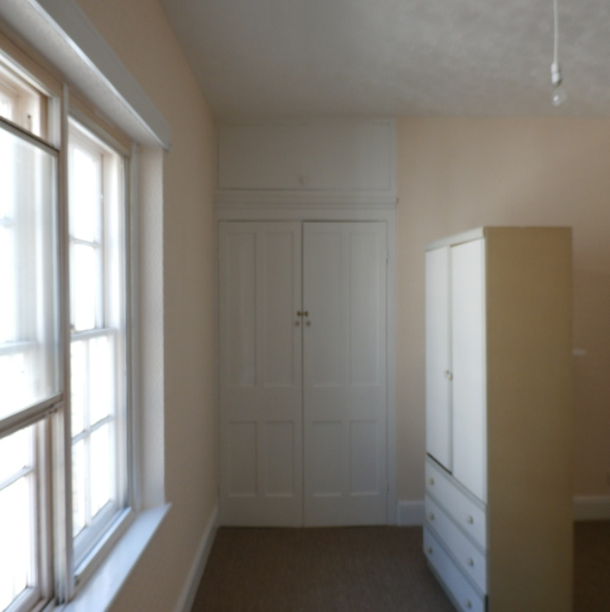
Photo 19 Photo 20

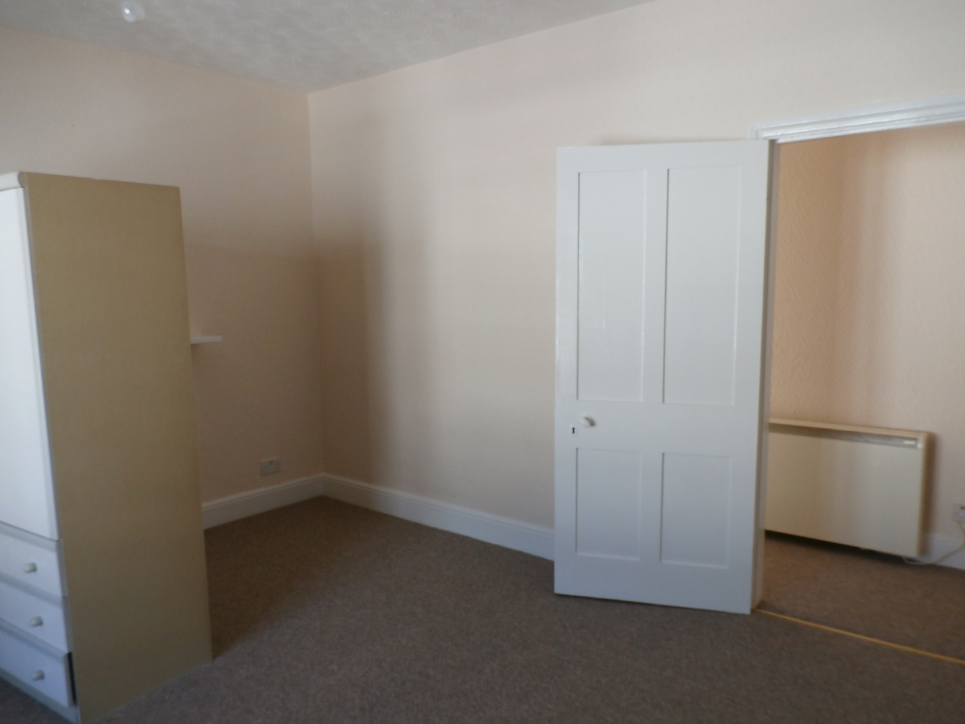
Photo 21
Landing (photo 22) – Newlec wall mounted electric heater, access to roof space via hatch, and emergency light.
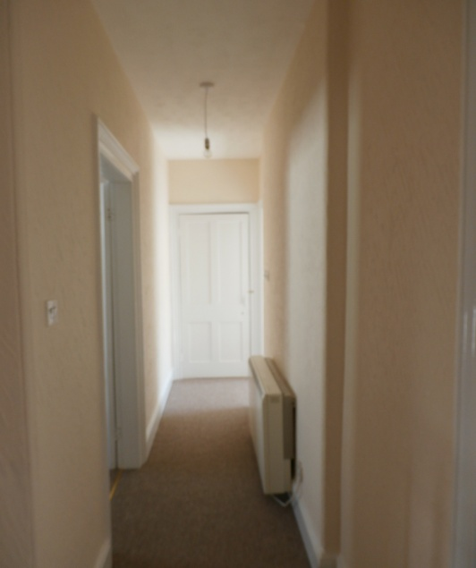Photo 22
Bathroom (photos 23-27) – over-sink light/shaver point, small wash basin, MIRA Sport electric shower over bath, shower panel, electric heated towel rail, low level WC and cistern, Dimplex wall mounted heater (working) and ceiling light fitting.
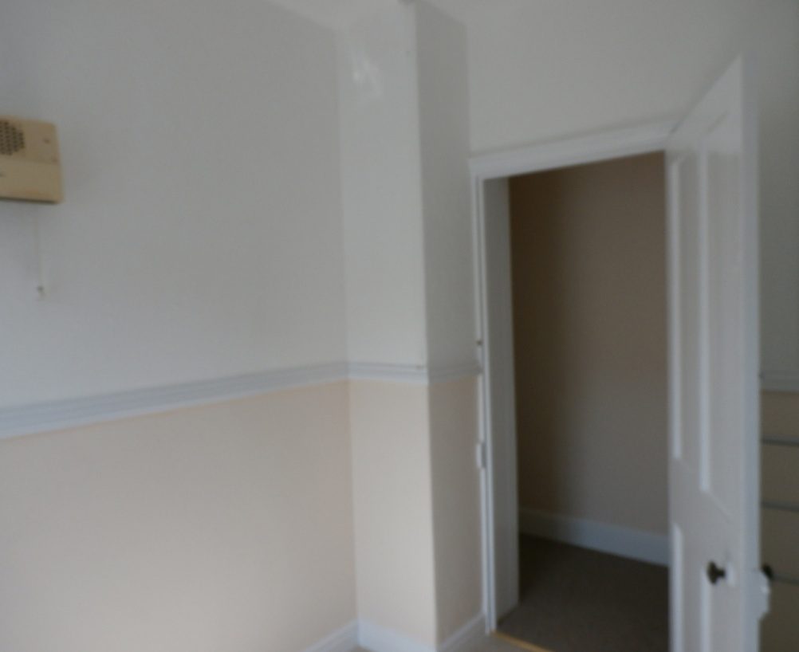
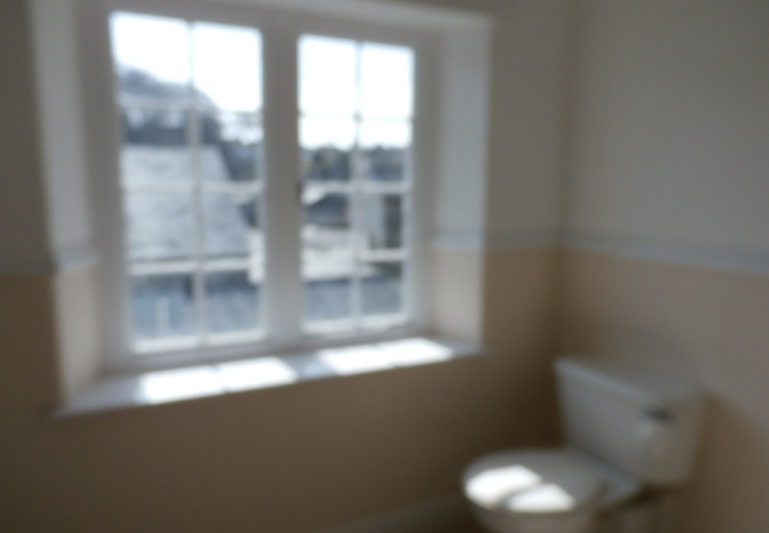
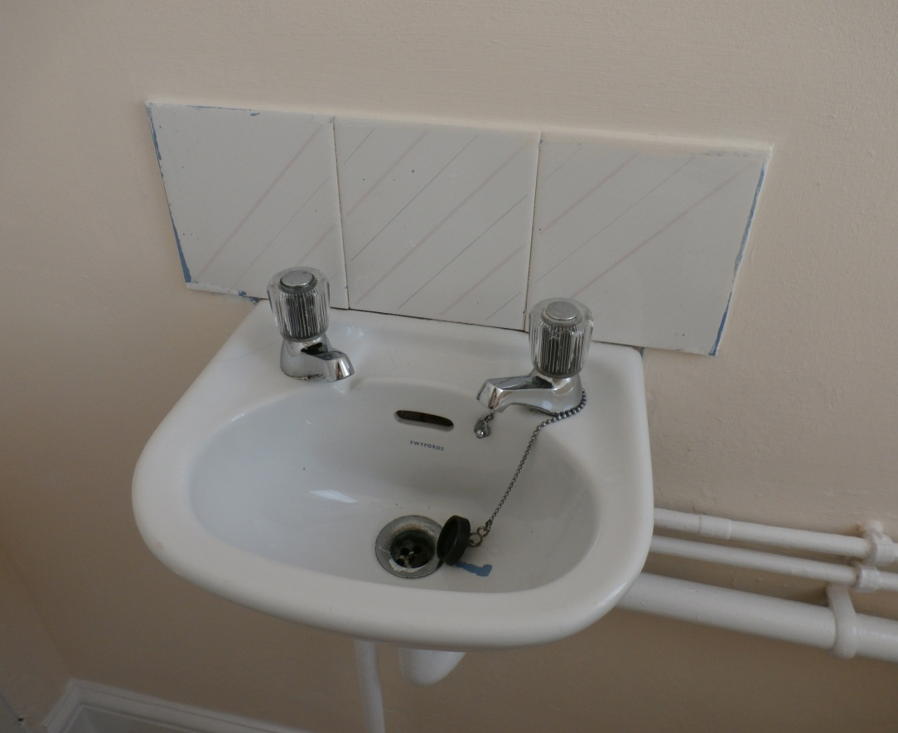
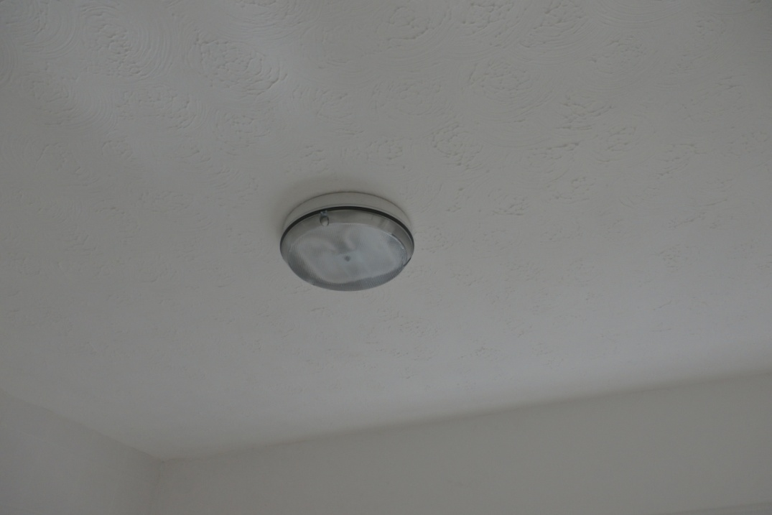
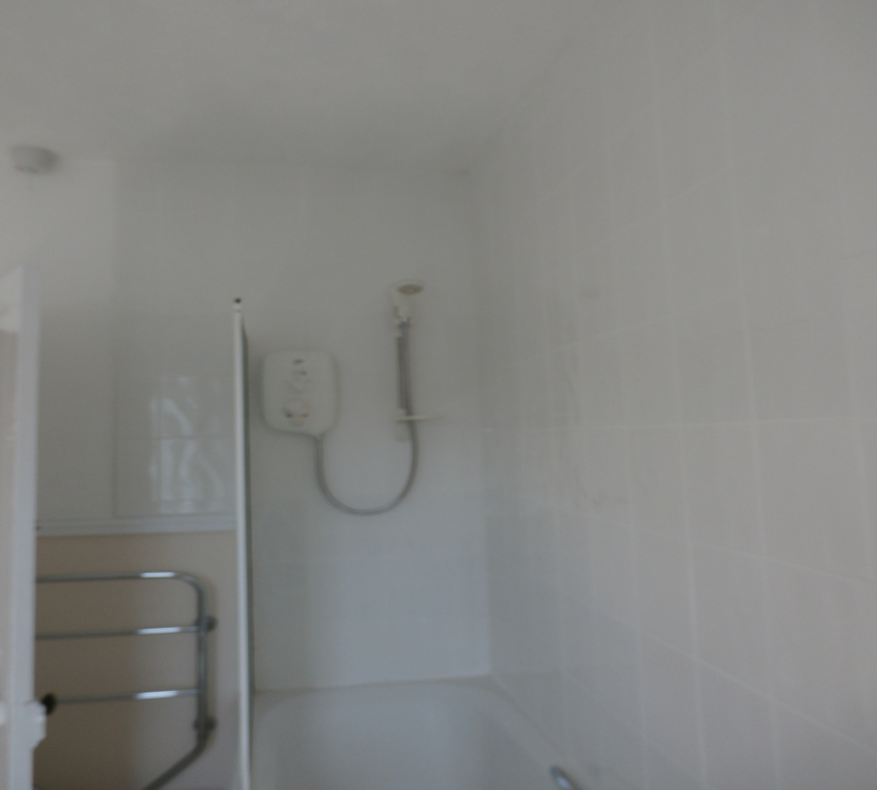
Photos 23 – 27
Airing cupboard (photos 28 & 29) – 900x450 Direct Combination Unit Tank. An electricity smart meter has been installed.
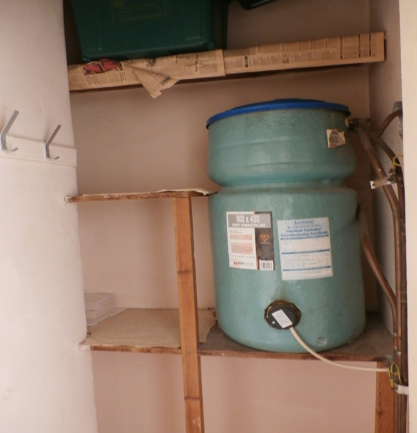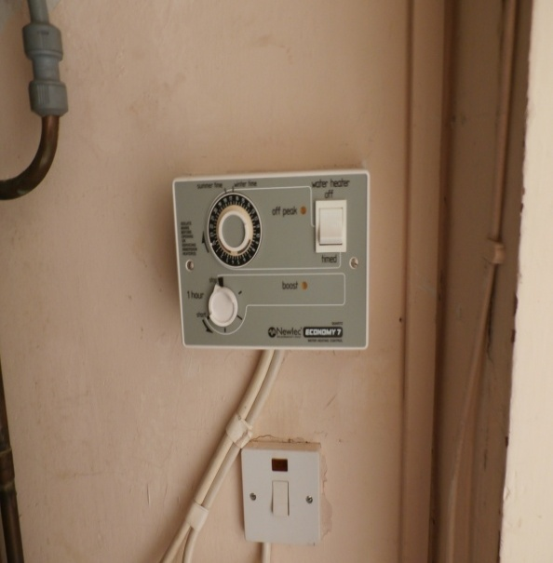
Photo 28 Photo 29
Electricity and water meters are in the basement of the shop next door.

