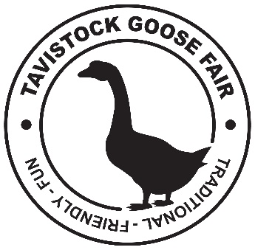

FOOD SAFETY CHECK LIST FOR FOOD BUSINESSES OPERATING AT TAVISTOCK GOOSE FAIR 2022

FOOD SAFETY CRITERIA | TICK
1. Is my food vehicle or trailer designed and constructed so as to avoid the risk of contaminated foodstuffs?
2. Is my food vehicle/trailer kept clean?

Are all items of equipment kept clean?
3. Is there adequate provision for hot temperature storage of food products,
i.e. above 63° C?
4. Is my food vehicle or trailer kept in good repair?
5. Are food products protected from the risk of contamination? (Are sneeze guards provided?)
6. Are adequate provisions made for cleaning of utensils, equipment and food,
i.e. sinks?
7. Is there a wash hand basin?
8. Is there adequate and portable supplies of hot and cold water?
9. Are staff engaged in handling food products trained in food hygiene?
10. Are staff provided with suitable protective clothing?
11. Have I carried out a hazard analysis of my operation?
12. Do I have a sign displaying my name and address on or within the stall?

