Memorial Application Form
If you would like to dedicate a bench or a plaque as a memorial or to commemorate a special occasion please complete the application form and return to the Works Manager for consideration.
Please be advised there are two designs of bench available, a simple bench design for Whitchurch Down and a formal bench design for all other areas. No other design is permitted except with the permission of Tavistock Town Council. A brass (or suitably agreed equivalent material) plaque, no larger than 12cm x 8cm, must be supplied by the applicant and the wording must be accepted by the Council. The bench will be maintained on request by Tavistock Town Council for a maximum period of 10 years. The cost of a bench is £550 + VAT.
Name and Address of Applicant:

Telephone Number: |  | Email Address:
Location Information:
Please give up to three preferences of where you wish the memorial Bench or plaque to be sited. Please be as descriptive as possible and include a photo if possible
Preference 1:

Preference 2:

Preference 3:

Details of Dedication (to go the plaque): Please print clearly and use BLOCK CAPITALS

Signature of Applicant:..……………………………………………………Date:…………………
Please return the completed application form either by post to; THE WORKS MANAGER, TAVISTOCK COUNCIL OFFICES, DRAKE ROAD, TAVISTOCK PL19 0AU or alternatively VIA email: worksdepot@tavistock.gov.uk
Once your completed application form has been received by Tavistock Town Council, it will be passed to the Works Manager to consider the application and location(s) of the request.
Please allow up to four weeks for this process to be completed and for the Works Manager to respond to your request.
Unfortunately, we are unable to grant all requests. We will however, try to accommodate all requests where possible. Should your application be successful you will be required to sign an agreement stating you agree to the terms and conditions set by Tavistock Town Council. Please note the dedication detailed on this form cannot be amended once submitted unless formal agreement has been reached with the Works Manager and permission is granted.
Full payment is required with the submission of the signed agreement.
If the agreement and payment is not received by Tavistock Town Council within 3 months of the formal response date then the application will be cancelled and a new application enquiry will have to be made.

Thank you
Works Manager
Tavistock Town Council
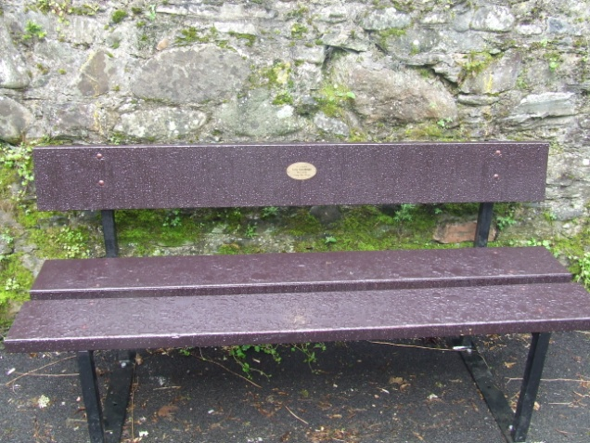
Formal Bench Design

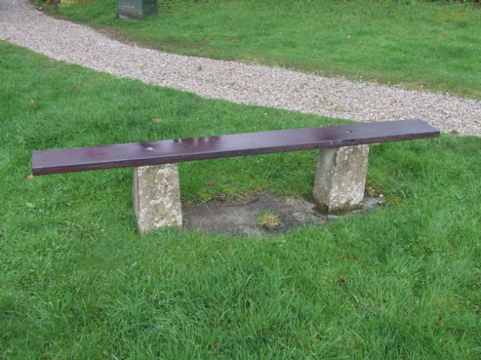
Simple Bench Design

